Microsoft Azure IOT Services

## **Defining Internet of Things**

The Internet of Things (IOT) is the network of physical objects (devices, vehicles, buildings and other items) embedded with electronics, software, sensors, and network connectivity that enables these objects to collect and exchange data. — [**Wikipedia**](https://en.wikipedia.org/wiki/Internet_of_things)

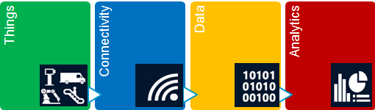

Data is exchanged in following modes

* **Telemetry** — An automated communications process by which measurements and other data are collected at remote or inaccessible points and transmitted to receiving equipment for monitoring.
* **Notifications** — Deliver notifications of specific events, scenarios or activities to target audience to offer the best user experiences and meet customer needs.
* **Command/Query** and Inquiries — Enable Action at a Distance.

## **What IOT Provides?**

**Data-Driven Insight (“Telemetry”) :**More efficient use of resources (predictive maintenance – reduce cost, environmental impact),  More targeted products and services (increase revenue, social impact). => “Things” = a rapidly expanding source of raw material for the Insight pipeline

**Action at a Distance (“Command & Control”):**Engage with customers beyond the point of sale, Preventive maintenance, Best practices guidance, Proactive sales, Remote servicing etc.=> From CRM to PRM – “Product Relationship Management”

**Intelligent Push Notification for Converged Mobile Computing and Internet of Things:**Distribute interesting information to target audience/users timely.

## **Why IOT?  (E.g. Case Study – Manufacturing industry)**

| **Challenge** | **Solutions** | **Benefits** |
| --- | --- | --- |
| No direct connection with majority of installed base, which leads to a reactive customer service from the OEM with relatively inefficient resolution processes. | Monitoring –visualizing real time data. | Optimize cost structure for service organization through new capabilities like e.g. Remote Monitoring and Reporting, Remote Support and Diagnostic |
| Equipment Maintenance schedules are based on defined time-intervals which is the reason that services are performed to often, to early or to late. | Reporting –Analyzing and visualizing historical data. | Provide new consulting services or business process outsourcing. |
| Service costs grow linear to the number of installed machines. Similar learning curves like in production for service operation necessary. | Prediction – predicted events. | Deepen customer relationship management and improve customer loyalty. |
|  | Alarming –sending information to people. | Improve overall equipment, machine and device performance and safety. |
|  | Guidance –real time communication. |  |
|  | Repair –sending controls to the machine. |  |
|  | Portal –information & collaboration platform. |  |
|  | Mobility –mobile access from anywhere. |  |
|  | Integration –Integration with other Enterprise IT Systems. |  |

## **Why IOT?  (Case Study)**

|  |  |
| --- | --- |
| ThyssenKrupp | ThyssenKrupp Elevator is sending data from elevators into dynamic predictive models, which continually update data sets via seamless integration with Azure.  When the elevator reports that it has a problem, it sends out an error code and the three or four most probable causes of that error code. In effect, field technicians are being coached by this “expert citizen.” |
| Rockwell Automation | Rockwell Automation is using Microsoft Azure IoT services to develop cloud-based solutions that predict equipment failures along the oil and gas supply chain, track performance in real time, and help prevent failures in the future. |
| Lido Stone Works | To meet demand for premiere architectural stone products, the owner of Lido Stone Works needed to automate his factory. He realized the potential of IoT, creating an intelligent system that connects the factory’s machines with the experts in Italy who built them. By harnessing the resulting flow of data via a secure, cloud-based connection, Lido has drastically cut maintenance costs.  The Internet of Lido’s Things has transformed the business, increasing productivity by 30 percent and revenue by 70 percent. |

## **IOT Opportunity**

Today’s businesses must build a data strategy to harness the power of data.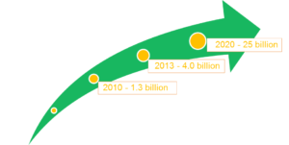

* 25 Billion connected things by 2020 – Gartner
* $1.7 Trillion market for IOT by 2020 – IDC (International Data Corporation)

## **Microsoft Azure IOT Services**

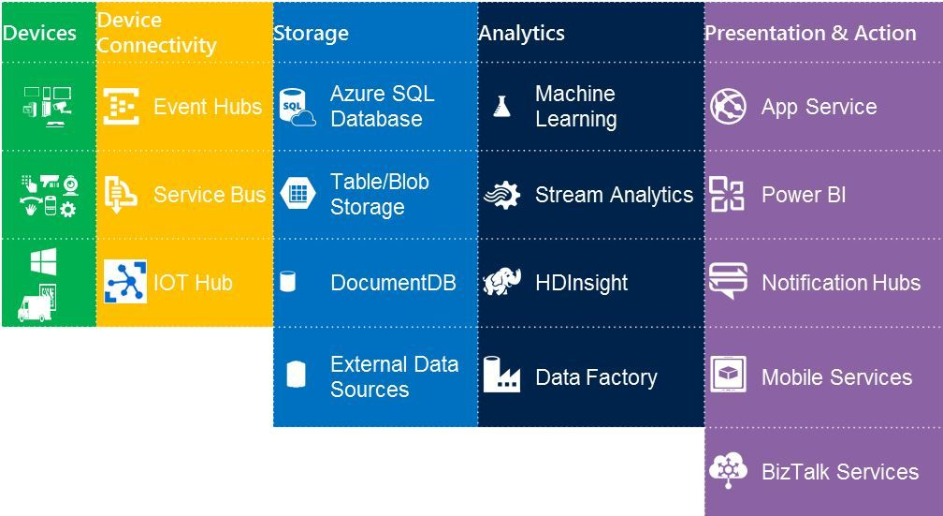

| **IOT Service** | **Description** |
| --- | --- |
| IOT Hub | Establish bi-directional communication with millions of IoT devices |
| Event Hubs | A scalable service for ingesting and storing data from line-of-business assets and sensors. |
| Document DB | A No-SQL document database-as-a-service that helps enable fast deployment of IOT applications that are flexible and scalable, handle a diversity of data, and run in a trusted cloud environment. |
| Stream Analytics | A real-time distributed stream computation service that provides low-latency, scalable processing of streaming data in the cloud with an enterprise-grade service-level agreement. |
| Notification Hubs | A scalable, mobile-push notification engine for quickly sending millions of messages to iOS, Android, or Windows devices. |
| Machine Learning | cloud-based predictive analytics. |
| HDInsight | A Hadoop distribution powered by the cloud to process unstructured or semi-structured data from web clickstreams, social media, server logs, devices and sensors, and more. |
| Power BI | A self-service analytics tool for all your data. |

## **Telemetry – End to End Solution**

* High scale data ingestion
* High scale stream processing via Stream Analytics (or HDInsight )
* Storage for cold-path analytics (SQL)
* Processing for hot-path analytics (Power BI)

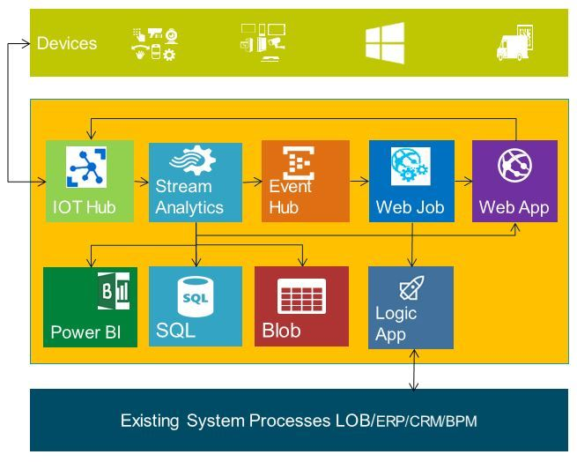

## **IOT Hub, Event Hub, Stream Analytics**

|  |  |
| --- | --- |
| IOT Hub | Establish bi-directional communication with millions of IOT devices  Use standard and custom protocols, including HTTP, Advanced Message Queuing Protocol (AMQP) and MQ Telemetry Transport (MQTT).  Provides per-device identity and revocable access control.   With new device management capabilities in Azure IOT Hub, administrators can remotely maintain IOT devices.  Is optimized to support millions of simultaneously connected devices.  The IOT Gateway SDK offers a powerful framework for large variety of languages. |
| Event Hub | Telemetry ingestion (Device to Cloud) from websites, apps, and devices  Compatible with protocols like HTTP, AMQP and MQTT  Can support a more limited number of simultaneous connections--up to 5,000 AMQP connections |
| Stream Analytics | Real-time analytics for Internet of Things solutions  Stream millions of events per second  Mission critical reliability, performance and predictable results  Rapid development with familiar SQL-based language |

## **Microsoft Azure IOT Suite (Pre-Developed sample Solutions, Framework, SDK)**

**Microsoft Azure IoT Suite**to help customers more easily deploy IoT solutions with broad support a variety of devices and systems, interactive dashboards and visualizations, and preconfigured solutions.

Now enterprises have an easy and seamless way to connect people, devices and assets that help them realize the opportunities of IoT without massive investments in infrastructure that would slow time to value. <http://www.azureiotsuite.com/>

**Why Microsoft IOT Suite**

* Enables you to Manage Dashboards, Devices, Rules, Actions with SDK.
* By default Creates separate resource group to manage resources required for IOT solution.
* Comprehensive solution: Connect millions of devices and integrate your business systems with new insights to transform your business
* Accelerate Time to value: Get started quickly with preconfigured solutions for common IOT scenarios.
* Rich Partner Network: Leverage a worldwide ecosystem of experienced IOT partners to tailor IOT solutions to your needs.

## **Best Practices for Creating IOT Solutions with Azure**

**Pattern: Think big.  Start small (Experiment, learn and refine)**

* Build an architecture that will scale, but start prototyping with a small number of devices.
* It’s hard to predict what data provides value — which impacts which sensors and devices are necessary — until you build something.
* It’s much easier to work through device identity, management/update and security at small scale.

**Pattern: Telemetry first**(Start with telemetry. The important data may not be what you expected. Address privacy, security and manageability before moving to command and control.)

* It is very hard to predict in advance what data will be useful.
* It is tempting, but likely inefficient to try for business transformation in the first step.
* Think about not only device telemetry but also diagnostic telemetry.
* Privacy and security implications of telemetry are generally lesser than for command and control.

## **Next Steps**

**Roadmap**Microsoft is looking for customers and partners for IOT implementations!  
<http://azureiotpartners.azurewebsites.net/>  
Microsoft and third-party IoT services are being built today on Azure IOT Suite

**Learn more**<https://azure.microsoft.com/en-in/documentation/suites/iot-suite/><http://www.microsoft.com/en-in/server-cloud/internet-of-things/overview.aspx><https://azure.microsoft.com/en-gb/documentation/videos/azurecon-2015-introducing-the-microsoft-azure-iot-suite/>

**For Developers**<https://azure.microsoft.com/en-in/documentation/articles/iot-hub-csharp-csharp-getstarted/>

[https://azure.microsoft.com/en-in/documentation/samples/iot-hub-c-mbed-temperature-anomaly](https://azure.microsoft.com/en-in/documentation/samples/iot-hub-c-mbed-temperature-anomaly/)[/](https://github.com/Azure/azure-iot-sdks/blob/master/tools/DeviceExplorer/doc/how_to_use_device_explorer.md)

<https://github.com/Azure/azure-iot-sdks/blob/master/tools/DeviceExplorer/doc/how_to_use_device_explorer.md>

<https://github.com/Azure/azure-iot-sdks>

# [Important features of IoT Software Platforms](http://www.sharecareinspire.com/important-features-of-iot-software-platforms/)

## **Background**

The market for Internet of Things (IoT) platforms is rapidly evolving and with an ever increasing number of available platforms to choose from.

Article presents a general survey of current IoT software platform landscape based on the detailed analysis conducted on IoT vendors and highlights the comparison of key features that are important for any IoT software platform.

This article intends to help you with the following choices:  
**1.** Comparisons based on platform focus (analytics, mobile, device management and integrations)  
**2.** Narrowing down your platform requirements (end-to-end, open source etc)  
**3.** Filters based on feature sets, API, architecture, apps and pricing

## **Introduction**

[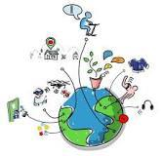](http://amzn.to/2rvDmlz)

The Internet of Things (IoT) has undergone rapid transformation since the term was first coined in 1999 by Kevin Ashton. Since the variety – and the number – of devices connected to the Internet have increased exponentially in recent years, IoT has become a mainstream technology with a significant potential for advancing the lifestyle of modern societies.

In terms of the technology and engineering aspects of IoT, there currently exists a clear separation between the hardware and software platforms, with the majority of vendors focused on the hardware. Few vendors in the industry currently offer IoT software platforms: for example, out of the top 100 IoT startups ranked by Mattermark (based on the total funding they received), only about 13 startups provide IoT software platforms.

Developing for the Internet of Things is a complex endeavor, and nobody wants to do it from scratch. IoT data platforms offer a jumping-off point by combining many of the tools needed to manage a deployment from device management to data prediction and insights into one service.

## **Important features expected from an IoT Software Platform**

As the world becomes increasingly connected, IOT platform is the key in developing scalable applications and services that connect ‘the physical and digital worlds’ in meaningful and productive ways, connecting disparate devices and applications, providing a single source for all industrial automation data in IoT solutions. The platform needs to centralize data from all instrumented assets, be integrated with enterprise IT systems and make data visible to key stakeholders so they can make better, faster decisions.

Choosing an IoT platform can be a challenging task in terms of becoming sufficiently knowledgeable about a specific vendor’s offering before getting both feet on board. Nearly as difficult is making an accurate comparison of IoT platforms by the brand since most of the available information is rooted from companies’ un-qualifiable marketing hype.

The real value of IoT for businesses lies in the data and each connected device can generate potentially millions of data points every day, but much of this data remains completely unused. Gathering and making sense of IoT data is no small task. Hence a careful investigation into the current IoT software platform landscape reveals that each of the above mentioned features have been implemented to different extents.

Based on several recent surveys, we have selected the following features as being crucial for an IoT software platform (as listed below) as example features for comparisons.

|  |
| --- |
| 1. Device management |
| 2. Application development |
| 3. Information Security |
| 4. Data Collection Protocol |
| 5. Data Analytics |

### **Device management**

[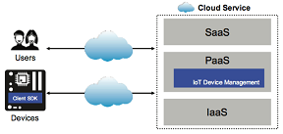](http://amzn.to/2rMrOKi)

Device management is one of the most important features expected from any IoT software platform. The IoT platform should maintain a list of devices connected to it and track their operation status; it should be able to handle configuration, firmware (or any other software) updates and provide device level error reporting and error handling.

Device management architecture must be bi-directional and flexible to allow for all network components to be connected, observed, and able to communicate. In the event of obsolescence, damage, or a security breach, the platform management system can remove or brick the device. At the end of the day, users of the devices should be able to get individual device level statistics.

### **Application development**

The life cycle of an app should be open-ended, able to create it, market it, and improve it over time. This “build-deploy-evolve” platform strategy should be enabled from the onset to support feedback loops and future iterations of the app function.

### **Integration Support**

The Support for integration is another important feature expected from an IoT software platform. The API should provide access to the important operations and data that needs to be exposed from the IoT platform. It is common to use REST APIs to achieve this aim.

### **Information Security**

[](http://amzn.to/2rvjlvH)

The information security measures required to operate an IoT software platform are much higher than general software applications and services. Millions of devices being connected with an IoT platform means we need to anticipate a proportional number of vulnerabilities. Generally, the network connection between the IoT devices and the IoT software platform would need to be encrypted with a strong encryption mechanism to avoid potential eavesdropping.

However, most of the low-cost, low-powered devices involved in modern IoT software platforms cannot support such advanced access control measures. Therefore the IoT software platform itself needs to implement alternative measures to handle such device level issues.

For example, separation of IoT traffic into private networks, strong information security at the cloud application level, requiring regular password updates and supporting updateable firmware by way of authentication, signed software updates , and so on can be followed to enhance the level of security present in an IoT software platform.

### **Data Collection Protocol**

Data collection protocol, another important aspect which needs attention is the types of protocols used for data communication between the components of an IoT software platform. An IoT platform may need to be scaled to millions or even billions of devices (nodes). Lightweight communication protocols should be used to enable low energy use as well as low network bandwidth functionality.

### **Data Analytics**

[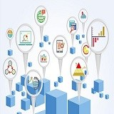](http://amzn.to/2tEAWBU)

The data collected from the sensors connected to an IoT platform needs to be analyzed in an intelligent manner in order to obtain meaningful insights.

There are four main types of analytics which can be conducted on IoT data:

• Real-time  
• Batch  
• Predictive and  
• Interactive analytics

Real-time analytics conduct online (on-the-fly) analysis of the streaming data. Example operations include window based aggregations, filtering, transformation and so on.

Batch analytics runs operations on an accumulated set of data. Thus, batch operations run at scheduled time periods and may last for several hours or days.

Predictive analytics is focused on making predictions based on various statistical and machine learning techniques.

Interactive analytics runs multiple exploratory analyses on both streaming and batch data.